Projeto I

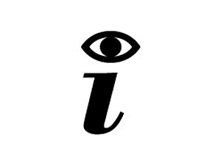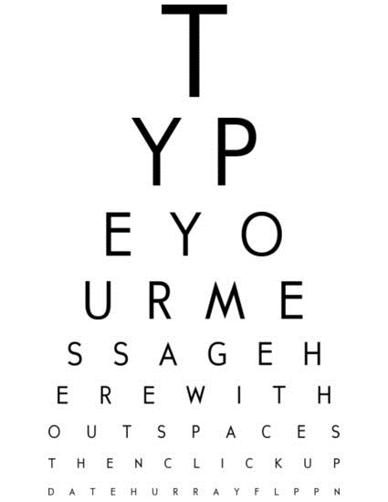 EST

**Group 6:**

Fábio Magalhães – A75030

Rui Carvalho – A76279

Index

Problem Statement 3

Market Study 3

Constraints 4

Technical Constraints 4

Functional Requirements 4

Non-Functional Requirements 4

Hardware Specifications 5

Software Specifications 5

System Overview 6

Events 6

Use Cases 7

State Chart 7

Sequence Diagram 8

System Stack 8

Gantt Chart 9

Problem Statement

In today society mankind is constantly using digital devices, that are affecting, negatively, vision health. It's been a concern for the past years to fight this era’s side-effect. To get yourself diagnosed, you must go to a doctor, which in public healthcare means a long wait and sometimes may be costly.

The Project’s goal is to design a tool to help diagnose irregularities in human vision, such as astigmatism, near-sightedness, and colour blindness. With only one device the user will be able to self-diagnose in an interactive and fast way.

We will have a screen showing images, that the user must identify. The device will recognise the answer and evaluate it. In the end of the test it will give you a result of how good or not your vision is.

Market Study

There are already a lot of vision diagnostics devices. Although these devices are all equipment that should be handle by a professional technician, we found some that compare to our project.

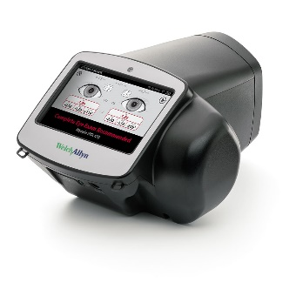*SPOT* Vision Screener:

Professional, portable device. Unlike ours, the device diagnoses the patient through a camera, screening the eye directly. This equipment is extremely expensive.

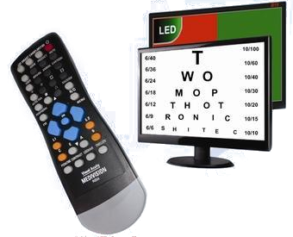*Medivision* Digital Acuity Chart:

Similar to our project, it displays the test in a screen. Although the diagnostic must be made by a doctor/technician, as the device will not give any. The device, though cheaper than *SPOT*, is still very expensive.

Resuming there exists already good devices that perform the task, but they are very expensive and they all need an experienced technician to use them.

Constraints

* Budget must be minimal.
* Project developed by a team of two.
* Project must meet the final deadline.

Technical Constraints

* STM32F4-DISCOVERY board
* Keil uVision MDK-ARM
* Digital Signal Processor (DSP)
* FreeRTOS
* Minimum of three sensors

Functional Requirements

* Diagnose User
* Display the vision test on the TFT screen.
* Detect user interaction.
* Measure the distance between the device and the patient.
* Check suitability of the ambient light.
* Recognise speech input data.
* Show malfunctions on the display.
* Give audio signals.

Non-Functional Requirements

* Low Cost and low power.
* User-friendly interface.
* Small and portable.
* The system must have low latency.

Hardware Specifications

* STM32f4 Discovery Board
  + STM32F407VGT6 MCU
  + 32-bit ARM Cortex-M4 CPU with FPU core
  + 1-Mbyte Flash Memory
  + 192-Kbyte RAM
  + MP45DT02 ST MEMS Digital Microphone
  + CS43L22 Audio DAC
  + Up to 17 timers
  + 3 ADC 12-bit (up to 24 channels)
  + General-Purpose DMA
* Light sensor
  + LDR 1K-10K Ω
* Ultrasonic distance measurement
  + HC-SR04
  + 2-400 cm of non-contact measurement
* MEMS Digital Microphone onboard
* TFT w/ Touchscreen
  + ILI9488 Display Driver
  + 320x480 Resolution
  + Resistive Touchscreen

STM32F4 Discovery Board

The STM32F4DISCOVERY Discovery allows development with the STM32F407VG high performance microcontroller with the ARM® Cortex®-M4 32-bit core.

Based on STM32F407VG, it includes an ST-LINK/V2 embedded debug tool, two ST-MEMS digital accelerometers, a digital microphone, one audio DAC with integrated class D speaker driver, LEDs, push buttons and a USB OTG micro-AB connector.

LDR

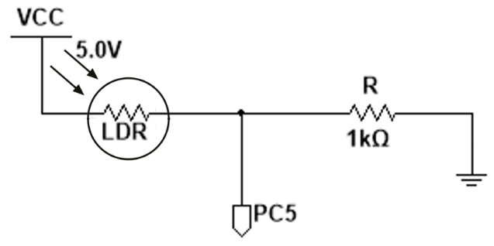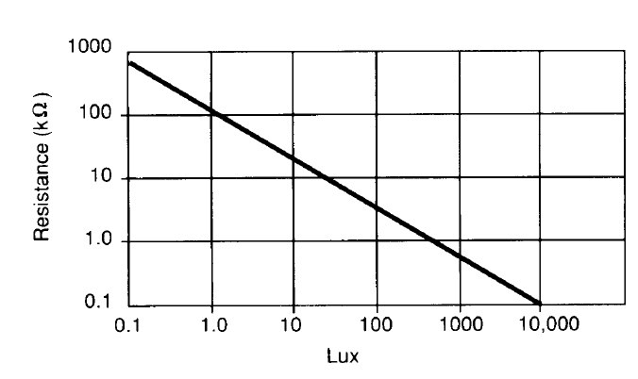

**Specifications**

|  |  |
| --- | --- |
| **Bright Resistance (100 lux)** | 5k Ω |
| **Dark Resistance (10 lux)** | 10k Ω |
| **Very Bright Resistance (100 lux)** | 400 Ω |
| **Max Voltage** | 150 V |
| **Max Power** | 100 mW |
| **Ambient Temperature Range** | -30 ~ +70 °C |

**Interface**

|  |  |  |
| --- | --- | --- |
|  | **Pin Name** | **Pin Function** |
| **LDR OUT** | PC5 | ADC12_IN15 |

**Test Cases**

Best ambient light (250 lux) -> 2.5k Ω

|  |  |  |
| --- | --- | --- |
| **Light Level** | **Expected Output** | **Real output** |
| Bright (100 lux) | 0.83 V |  |
| Dark (10 lux) | 0.45 V |  |
| Good Lighting (250 lux) | 1.43 V |  |

HC-SR04

**Specifications**

|  |  |
| --- | --- |
| **Working Voltage** | 5V |
| **Working Current** | 15mA |
| **Working Frequency** | 40KHZ |
| **Max Range** | 4m |
| **Min Range** | 2cm |
| **Measuring Angle** | 15° |
| **Trigger Input SIgnal** | 10us TTL pulse |

**Interface**

|  |  |  |
| --- | --- | --- |
|  | **Pin Name** | **Pin Function** |
| **Trig** | PA1 | Out |
| **Echo** | PA0 | TIM2_CH2 |

**Test Cases**

|  |  |  |
| --- | --- | --- |
| **Distance** | **Expected Output** | **Real output** |
| Min (2 cm) | 2 cm |  |
| Max (400 cm) | 400 cm |  |
| Reference (150 cm) | 150 cm |  |

MEMS Microphone

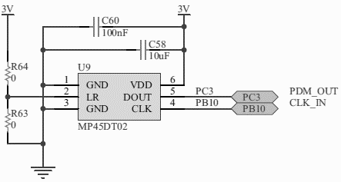

**Specifications**

|  |  |  |  |
| --- | --- | --- | --- |
| **Parameter** | **Min** | **Typical** | **Max** |
| Supply voltage | 1.6V | 1.8V | 3.6V |
| Current in normal mode |  | 0.65mA |  |
| Current in power-down mode |  | 0.20mA |  |
| Sensitivity | -29dBFS | -26dBFS | -23dBFS |
| Input clock frequency | 1 MHz | 2.4MHz | 3.25 MHz |
|  |  |  | 10ms |
| Low level logic input/output voltage | -0.3 V |  | 0.35*Vdd |
| High level logic input/output voltage | 0.65*Vdd |  | Vdd+0.3 |

**Interface**

|  |  |  |
| --- | --- | --- |
|  | **Pin Name** | **Pin Function** |
| **PDM Out** | PC3 |  |
| **Clock** | PB10 | TIM2_CH3 |

**Test Cases**

|  |  |  |
| --- | --- | --- |
|  | **Expected Output** | **Real output** |
| Speak to microphone | Voice input |  |

Display

ILI9488 Display Driver

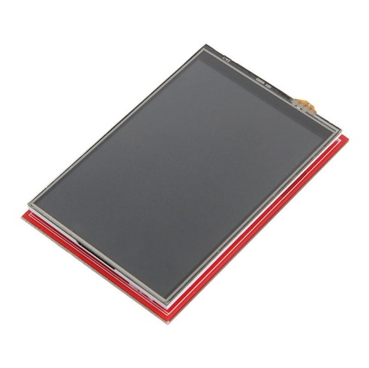SPI Compatible

**Specifications**

|  |  |
| --- | --- |
| **Resolution** | 320x480 |
| **Frame Memory** | 345 kbytes |
| **Input Image** | 24 bits |
| **IO VCC** | 1.65 – 3.3 V |
| **Temperature** | -40 ~ +85 °C |

**Interface**

|  |  |  |
| --- | --- | --- |
|  | **Pin Name** | **Pin Function** |
| **SCK** | PA5 | SPI1_SCK |
| **MISO** | PA6 | SPI1_MISO |
| **MOSI** | PA7 | SPI1_MOSI |

**Test Cases**

|  |  |  |
| --- | --- | --- |
| **Send Command** | **Expected Output** | **Real output** |
| 0x01 | Module Resets |  |
| 0x04 | Manufacturer, Version, ID |  |

Resistive Touchscreen

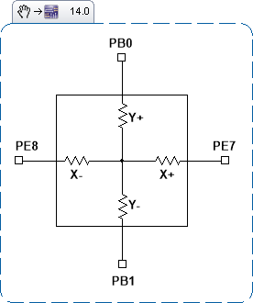 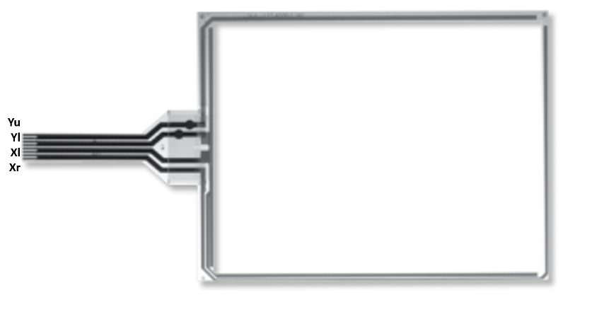

**Specifications**

|  |  |
| --- | --- |
| **Size** | 74*49 mm |

**Interface**

|  |  |  |
| --- | --- | --- |
|  | **Pin Name** | **Pin Function** |
| Y+ | PB0 | ADC12_IN8, GPIO IN/OUT |
| Y- | PB1 | ADC12_IN9, GPIO IN/OUT |
| X+ | PE7 | GPIO IN/OUT |
| X- | PE8 | GPIO IN/OUT |

**Test Cases**

|  |  |  |
| --- | --- | --- |
| **Touch** | **Expected Output (X,Y)** | **Real output (X,Y)** |
| Right Top Corner | 0,49 mm |  |
| Right Bottom Corner | 0,0 mm |  |
| Left Top Corner | 74,49 mm |  |
| Left Bottom Corner | 74,0 mm |  |

Software Specifications

* Keil uVison MDK-V5
* FreeRTOS
* C Language
* MatLab

System Overview

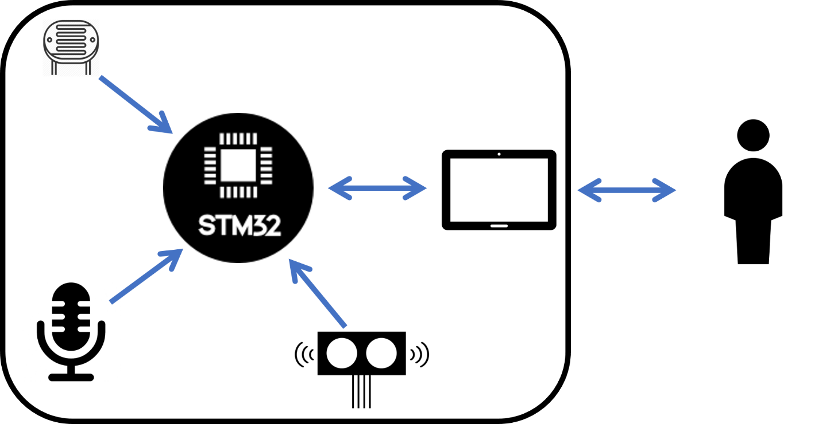

Events

|  |  |  |
| --- | --- | --- |
| Event | System Response | Source |
| On/Off | Turn System On/Off | User |
| Read Light | Reads ADC and processes data | Local Sys |
| Read Distance | Gets distance value | Local Sys |
| Display | Changes display data | Local Sys |
| Get voice | Gets and recognises voice input | User |
| Get Touch | Gets user input on touchscreen | User |

Use Cases

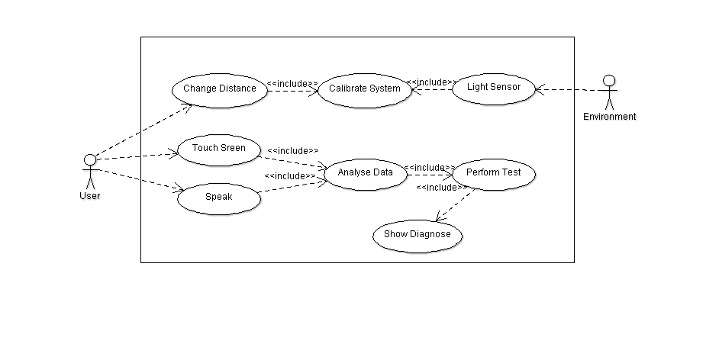

State Chart

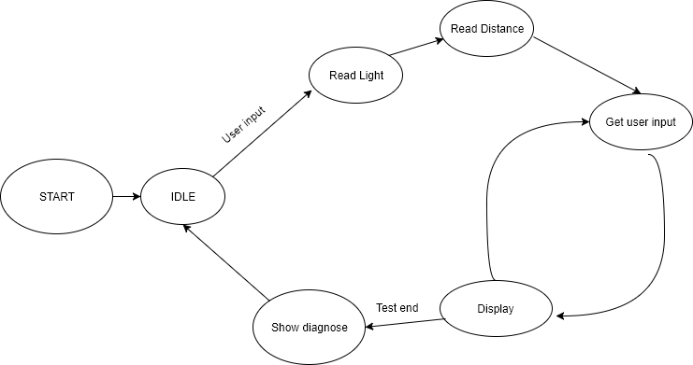

Sequence Diagram

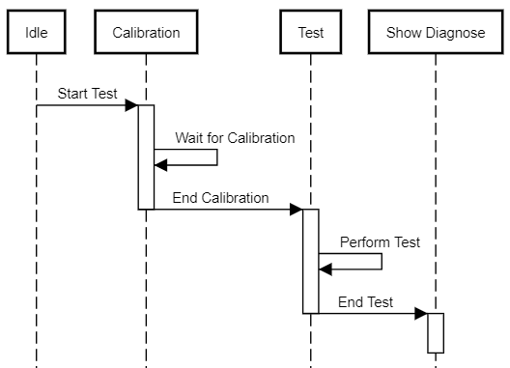

System Stack

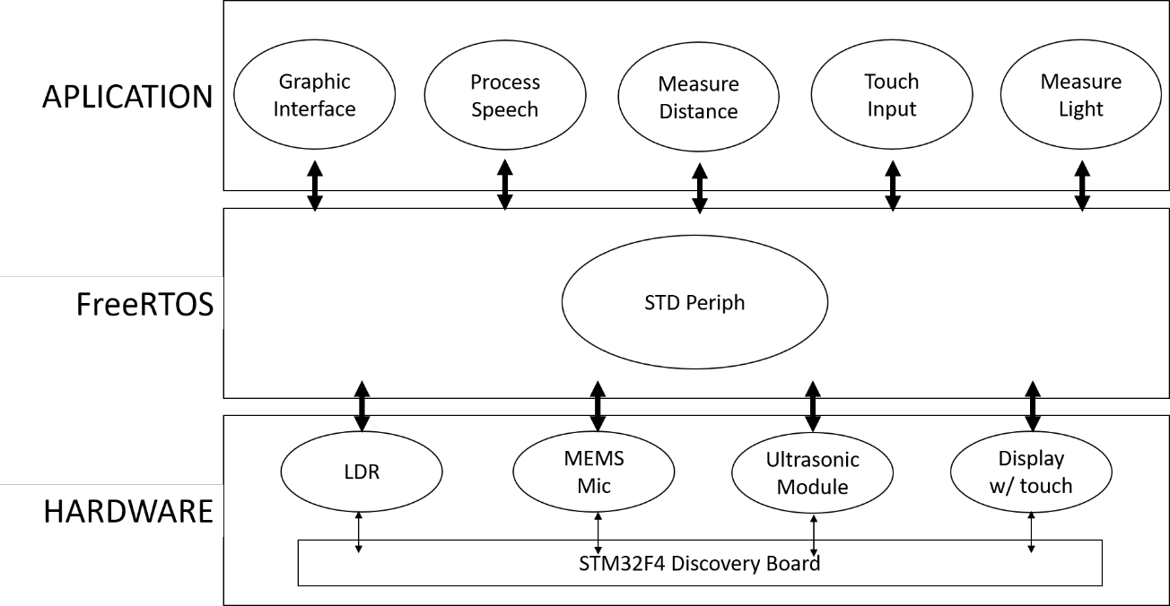

Task Priority

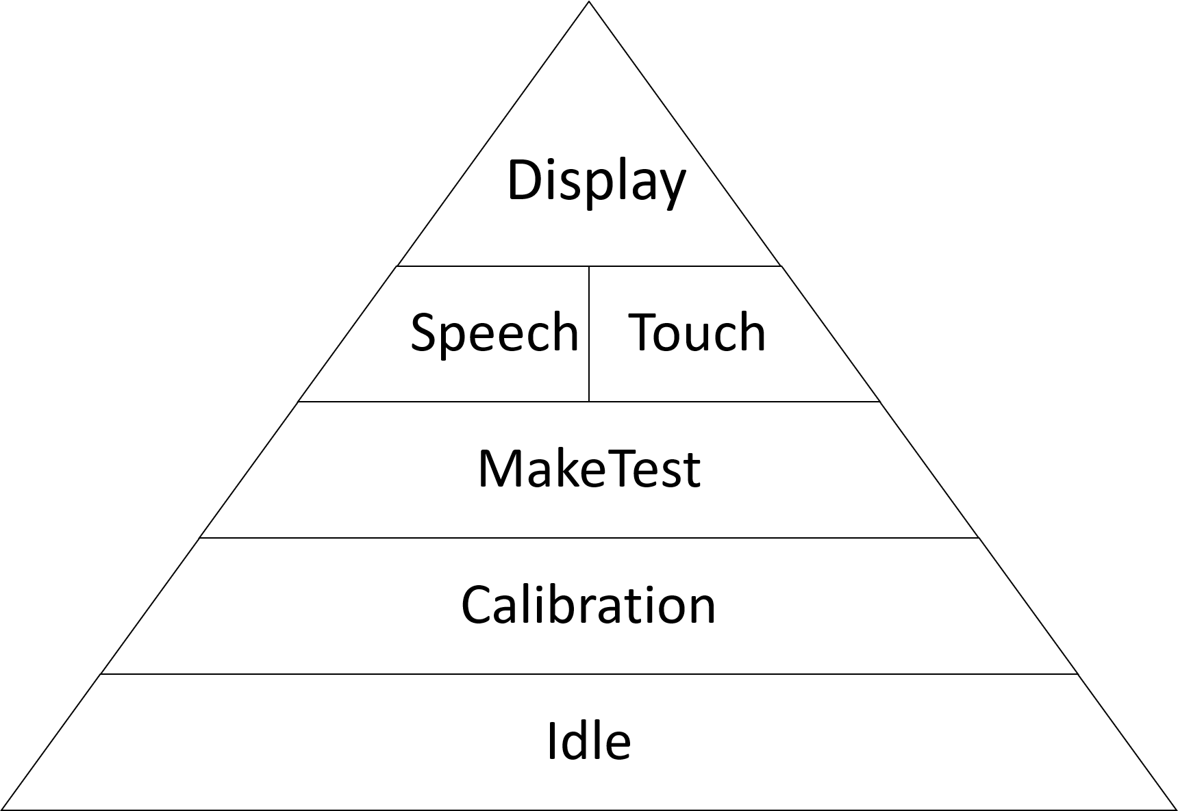

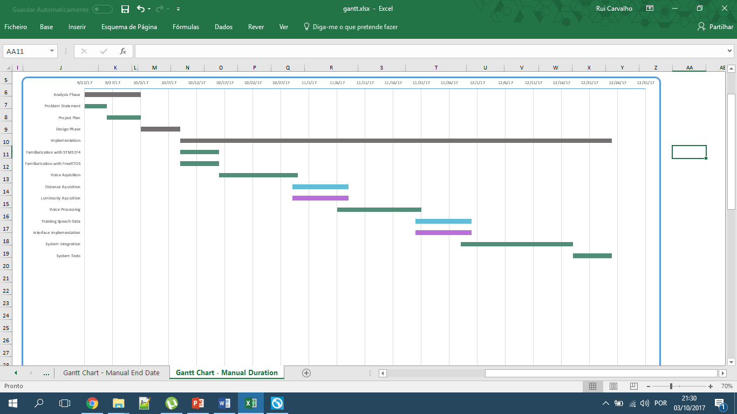Gantt Chart

